**Exp No: 2 Date: 31/07/2024**

**VIRTUALIZATION**

**VIRTUAL BLOCK, VM CLONE & VM SNAPSHOT**

**AIM:**

To configure a Virtual Block for a VM and then create a copy of VM through Cloning and perform a snapshot of VM.

**PROCEDURE FOR VIRTUAL DISK:**

1. Open the virtual machine settings editor (VM > Settings) and click Add
2. Click Hard Disk, then click Next.
3. Select Create a new virtual disk, then click Next.
4. Choose whether you want the virtual disk to be an IDE disk or a SCSI disk.
5. Set the capacity for the new virtual disk.
6. Accept the default filename and location for the virtual disk file
7. The wizard creates the new virtual disk. It appears to your guest operating system as a new, blank hard disk. Use the guest operating system's tools to partition and format the new drive for use.

**PROCEDURE FOR VM CLONE:**

1. Select the virtual machine you want to clone.
2. Open the Clone Virtual Machine Wizard (VM >Manage> Clone) and click Next.
3. Select the state of the parent from which you want to create a clone, and click Next.
4. Select the type of clone you want to create and click Next.
5. Type a name and a path for the cloned virtual machine, and click Finish. NOTE: You must power off a virtual machine before you can make a clone.

**PROCEDURE FOR VM SNAPSHOT:**

1. Choose VM > Snapshot > Take Snapshot

**OUTPUT:**

A Virtual block, Clone and Snapshot are created.

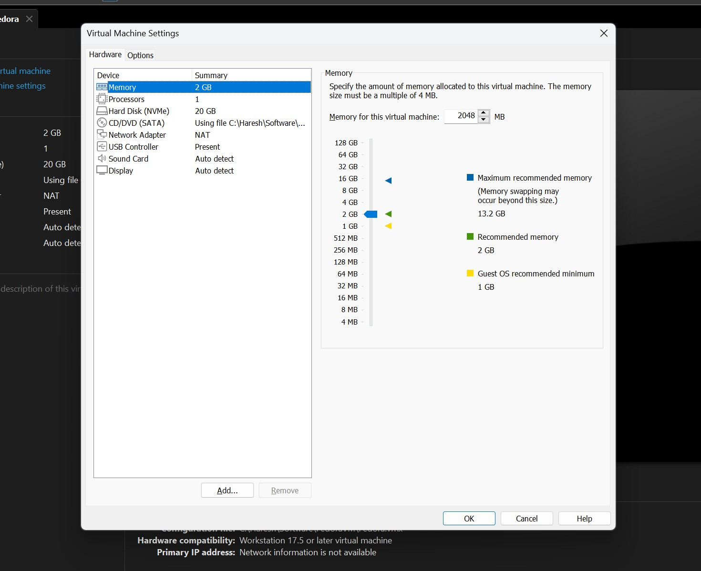

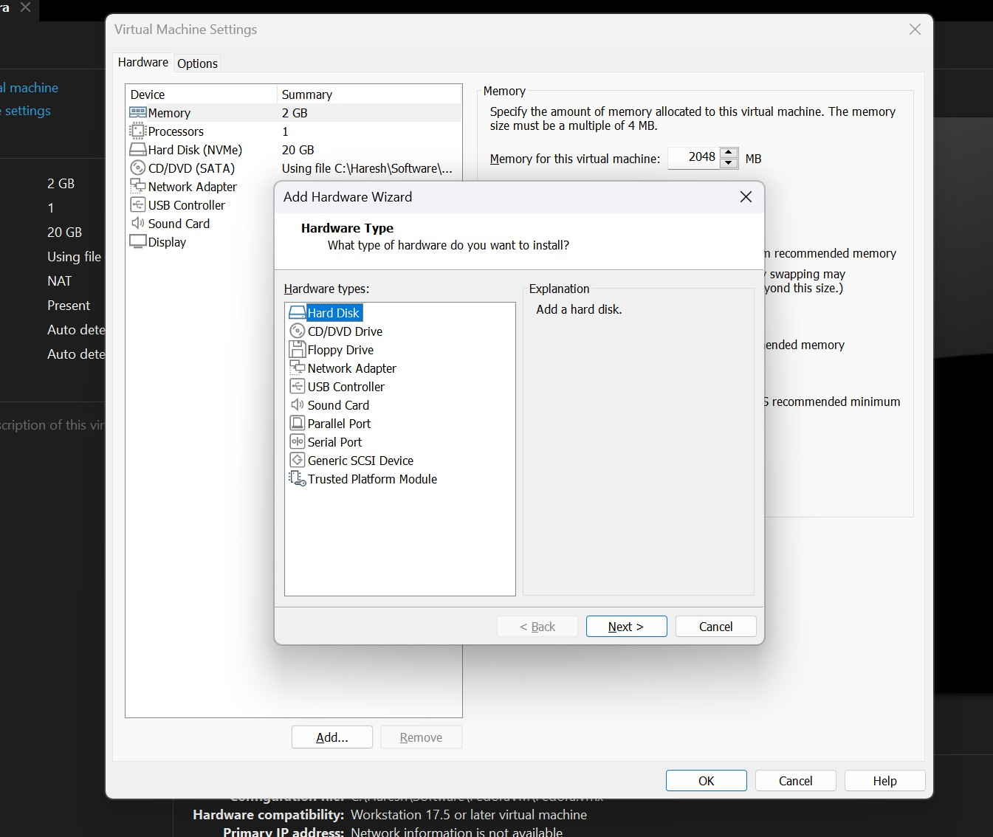

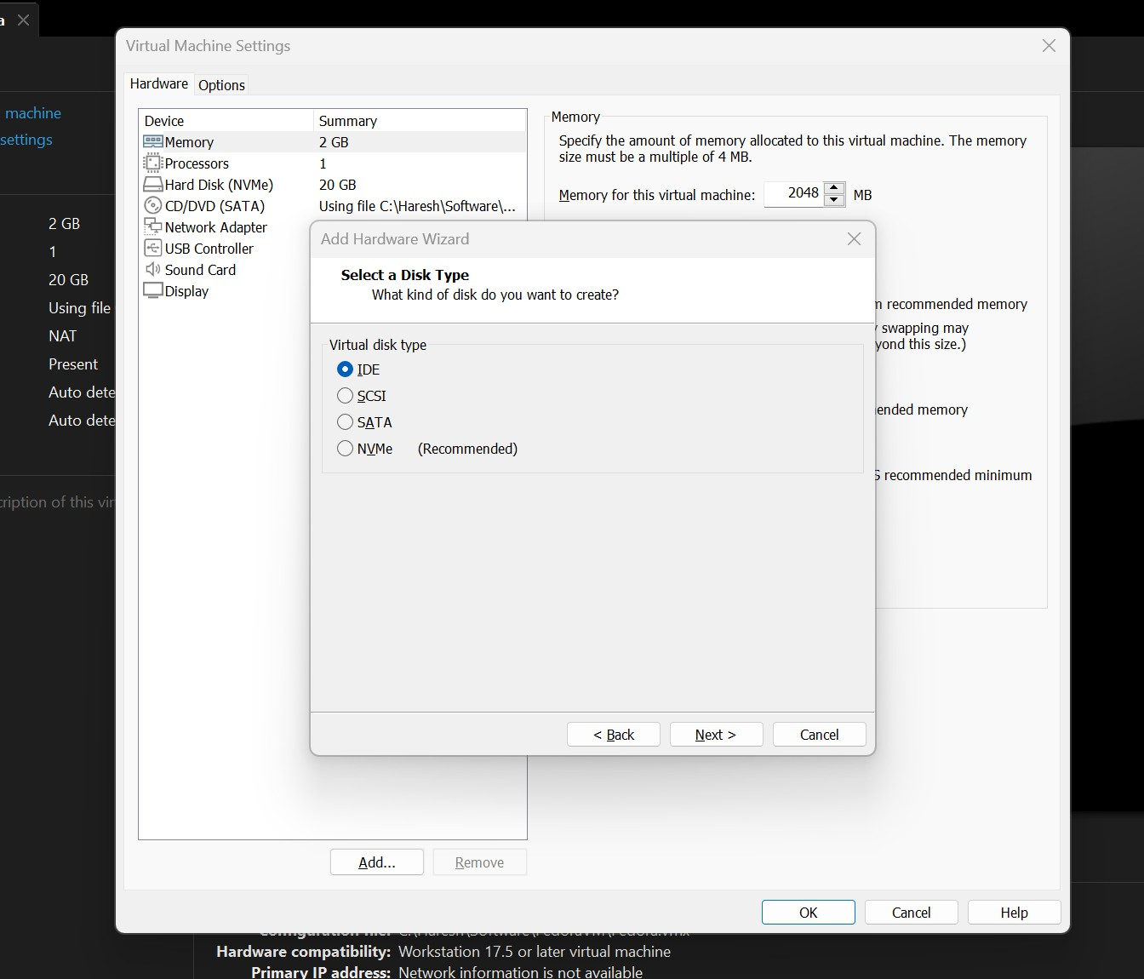

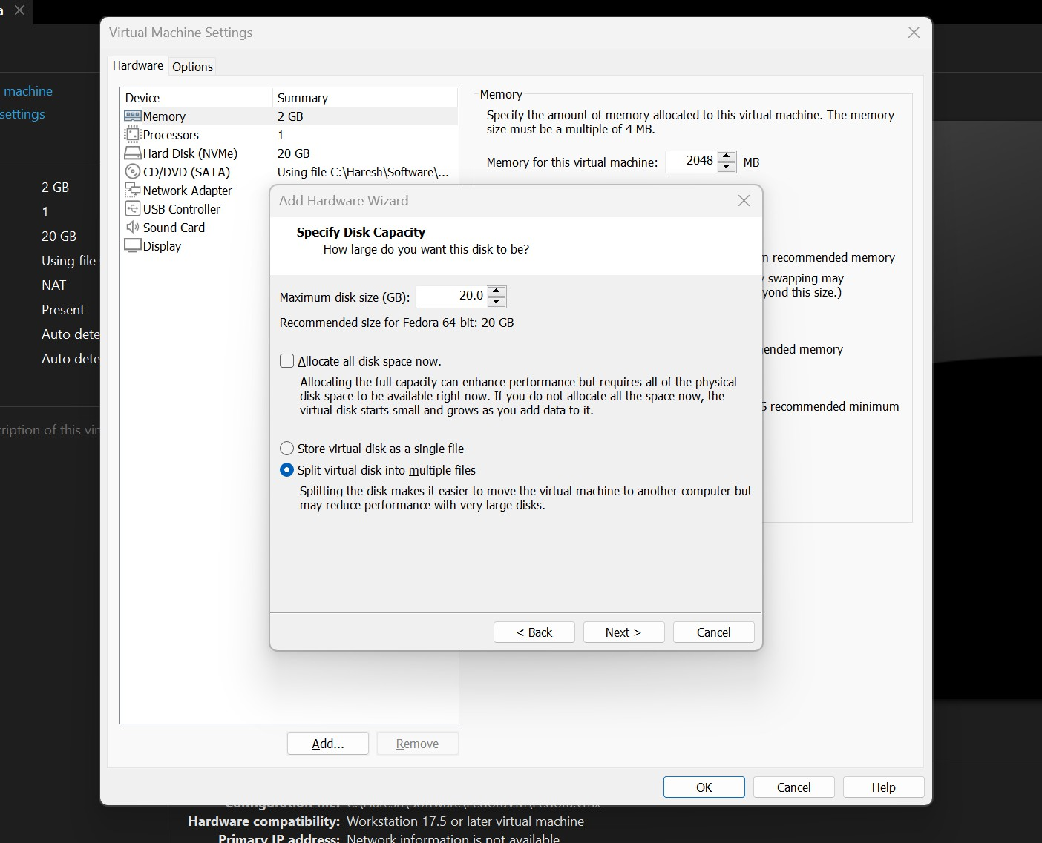

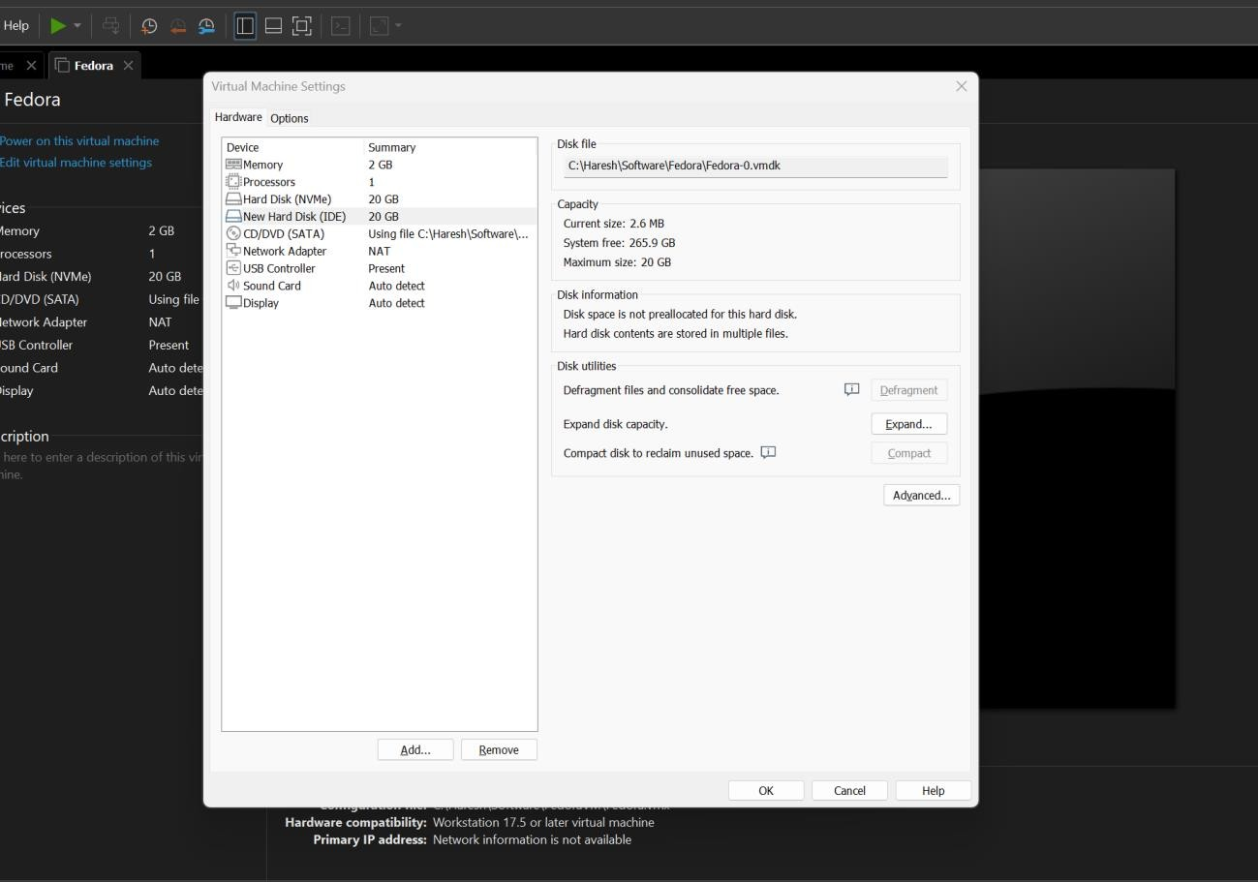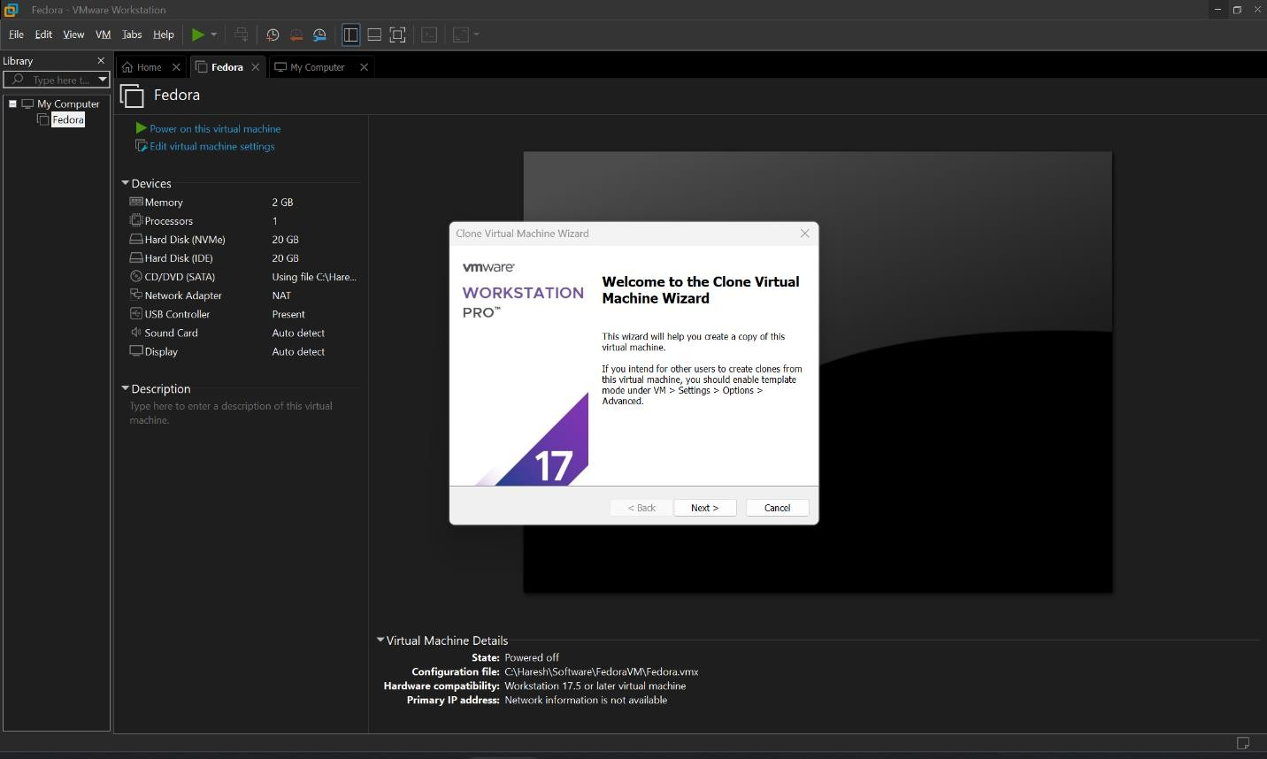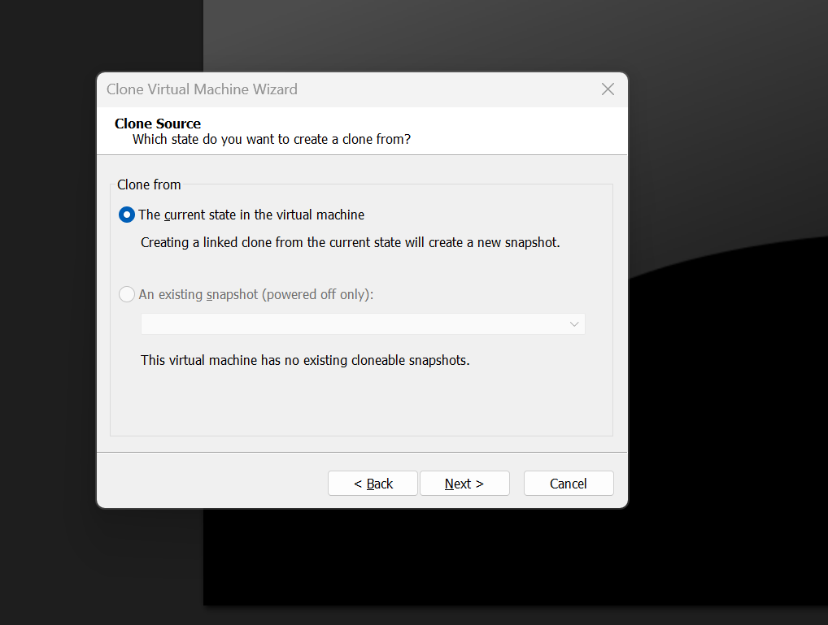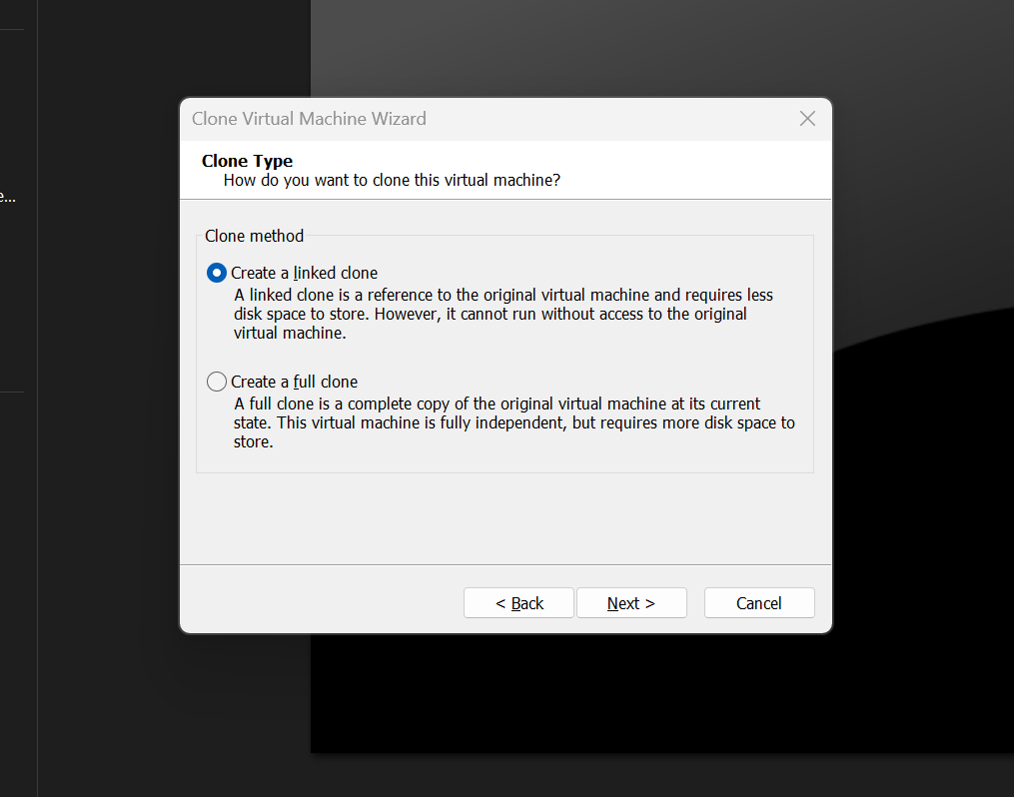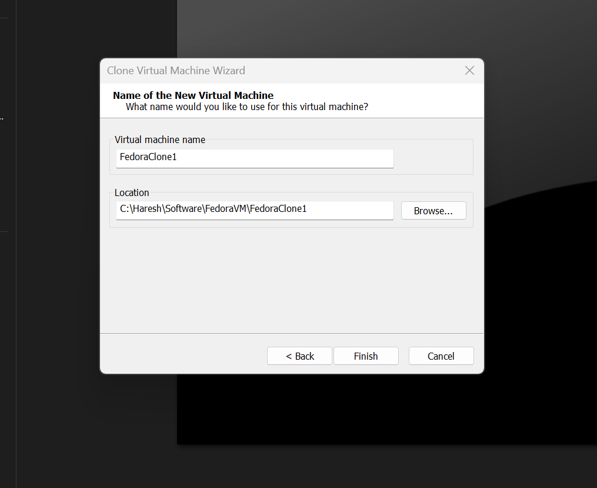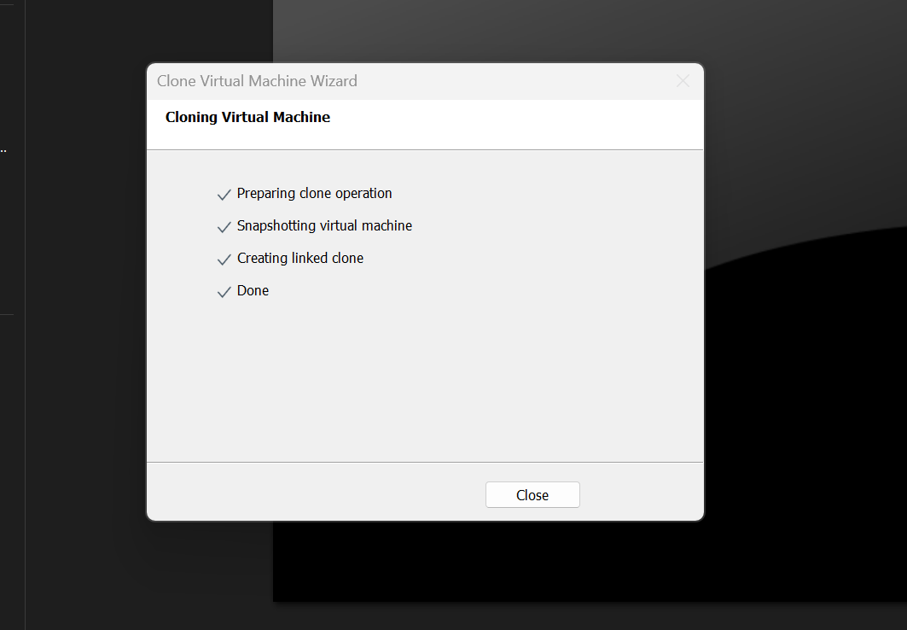

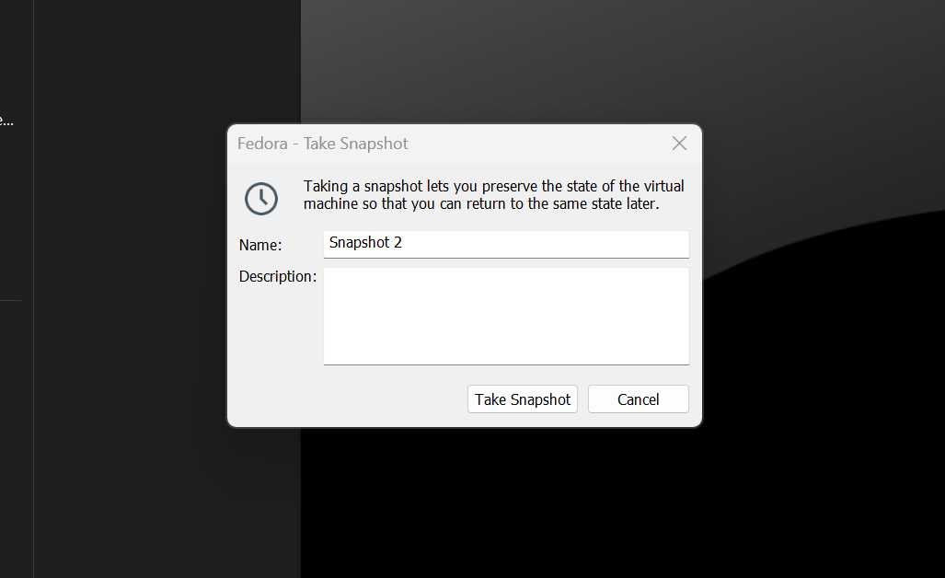

**RESULT:**

A Virtual block, Clone and Snapshot have been successfully created.